Name | Soham Joshi
Roll no | 24204C0021
Batch | 1
Subject name | Python Programming & Data Structure
Teacher Name | Ms. Rasika Patil

Experiments | 3
Title | *a) Develop python program to demonstrate use of control loops:  i) while  ii) do while  *b) Develop program to demonstrate use of for loop in python (e.g.: various pattern building, printing multiplication table, checking palindrome number etc.)
Theory
Looping constructs allow repeated execution of a block of code.
• While Loop runs as long as a condition is true.
• Do-While Simulation is implemented in Python using while True with a break.
• For Loop is used to iterate over sequences or ranges.
These constructs help build logic for patterns, number processing, and iterative operations.
Syntax
• while condition:
• for i in range():
• break
• continue

Here's an explanation of how they work and their significance in solving iterative problems:
1. for Loops:
- for loops are used when you know the number of iterations or when iterating over a sequence (e.g., lists, tuples, strings).
- They iterate over each item in a sequence, executing a block of code for each Iteration.

Syntax | Example
for item in sequence:  # Code block to execute for each item | numbers = [1, 2, 3, 4, 5]  for num in numbers:  print(num)
2. while Loops:
A while loop is used to repeatedly execute a block of code as long as a specified condition is true. It continues iterating until the condition becomes false.
Syntax | Example
while condition:  # Code block to execute while condition is true | num = 1  while num <= 5:  print(num)  num += 1

3. Nested Loops:
You can nest loops within each other to perform more complex iterations, such as iterating over nested lists or performing matrix operations.
Syntax | Example
for outer_variable in outer_sequence:  table # Code block for the outer loop for rows  inner_variable in inner_sequence:  # Code block for the inner loop space | # Nested loops to create a multiplication  for i in range(1, 6): # Outer loop for the  for j in range(1, 6): # Inner loop for the columns  print(i * j, end='\t') # Print the product with a tab  print() # Print a new line after each row

Loop Control Statements:
Python provides loop control statements to modify the behavior of loops:
- break: Terminates the loop prematurely, exiting the loop entirely.
for i in range(5):
if i == 3:b
break print(i)
- continue: Skips the rest of the current iteration and moves to the next iteration. for i in range(5):
if i == 3:
continue print(i)
- pass: Placeholder that does nothing. It is used when a statement is syntactically required but no action is needed.
for i in range(5):
pass # Placeholder for future code

Programming Questions with Answer
FOR LOOP
1 | Print multiplication table of a number
SCRIPT | 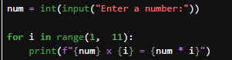
OP | 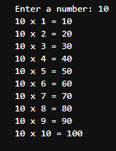
2 | Print a star pattern  * ** *** **** ***** * *** ***** *** * 1010101 10101 101 1
SCRIPT | 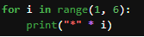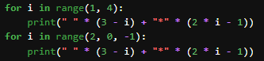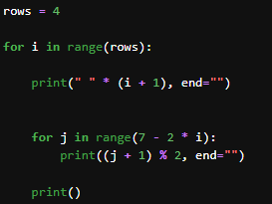
OP | 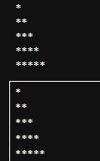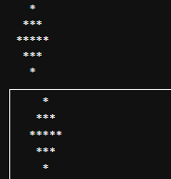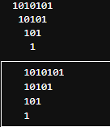
3 | Count digits in a number
SCRIPT
OP
WHILE LOOP
1 | Print numbers from 1 to 20
SCRIPT | 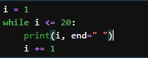
OP
2 | Sum of digits of a number
SCRIPT | 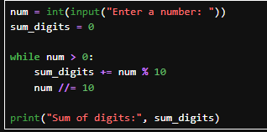
OP | 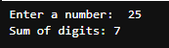
3 | Reverse a number
SCRIPT | 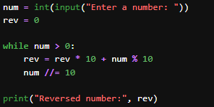
OP | 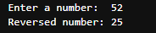
4 | Program to check if a number is a palindrome using for loop
SCRIPT | 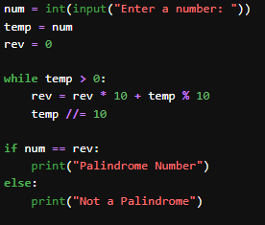
OP | 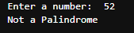
DO-WHILE SIMULATION
1 | Keep taking input until the user enters 0
SCRIPT | 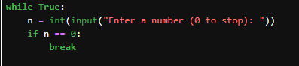
OP | 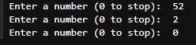
2 | Menu-driven calculator
SCRIPT | 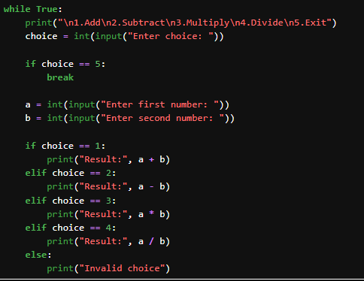
OP | 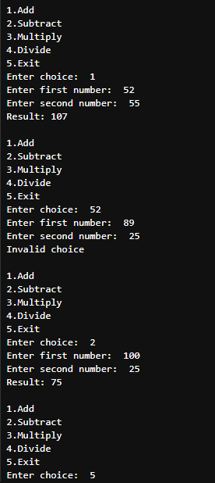
3 | Continue asking for password until correct
SCRIPT | 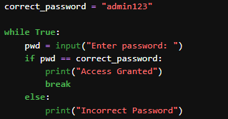
OP | 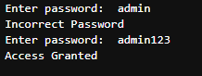
Debugging Questions with Corrected Answers
1 | Debug the following code  Wrong code:  i = 1  while i <= 5  print(i)  i = i + 1
OP | Error:  Correct code:  i = 1  while i <= 5:  print(i)  i = i + 1  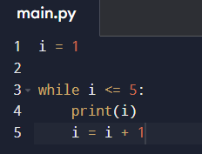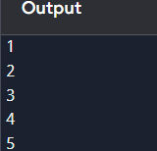
2 | Debug the following code  Wrong code:  for i in range(1, 10)  print(i)
OP | Error: invalid syntax. This occurs because the colon is missing at the end of the for i in range(1, 10) line.  Correct code: 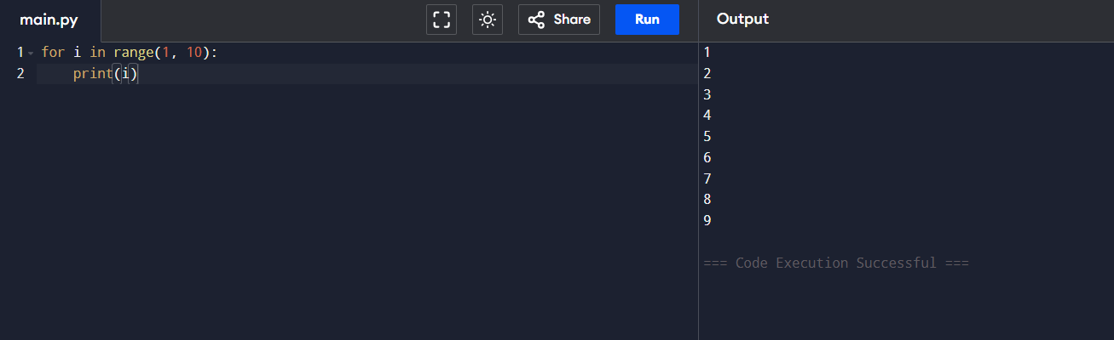
Conclusion

Performance Indicators |  | Teachers Dated and Signature
Process Related  (15 M) | Product Related  (10 M) | Total (25 M)

